Monarch Butterfly Migration
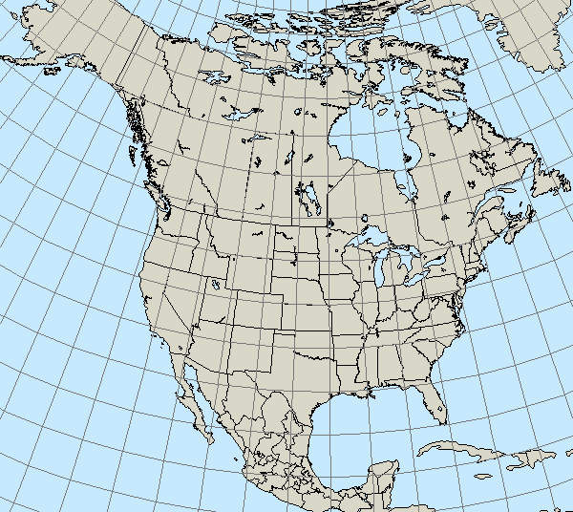

Reporter: _____________________

Date: ________________________

Progress of the Migration:

Location of Monarch Closest to Me:

Latitude: _____________

Longitude: ____________

Miles Away: _______________

I predict I will see my first monarch on _________ because ________

__________________________________________________________

My Headline: _______________________________________________

__________________________________________________________

Summary: _________________________________________________

__________________________________________________________

__________________________________________________________

Highlights Along the Migration Trail
Here is something new I learned about monarchs or something I’m wondering about:

